Pokhara University

Level: Bachelor | Semester – Spring | Year : 2009
Programme: BE |  | Full Marks : 100
 |  | Pass Mark : 45
Course: Applied Mechanics (Statics) |  | Time : 3 hrs

Candidates are required to give their answers in their own words as far as practicable.
The figures in the margin indicate full marks.

Attempt all the questions.

1. | - Draw shear force and bending moment diagram of given beam.  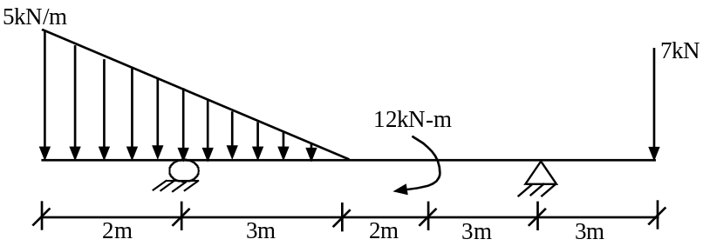  - Define S.F. and B.M. | 12  3
2. | Using the method of joints, determine the force in each member of the truss shown.  25 KN  25 KN  1.2 m  1.2 m  4.5 m  4.5 m  4.5 m  45 KN | 15
3. | - Locate the centroid of the shaded areas shown in figure below.  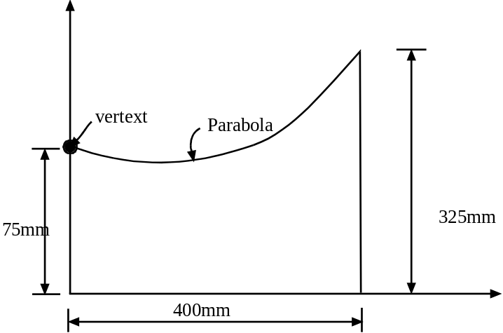  - Determine the moment of inertial of the given section about centroidal axes.  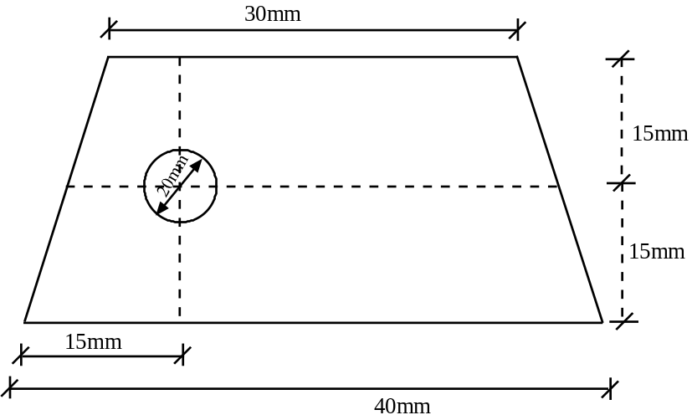 | 8  7
4. | A container of weight W is suspended from ring A, to which cables AC and AE are attached. A force P is applied to the end f of a third cable which passes over a pulley at B and through ring A and which is attached to a support at D. knowing that the tension in cable AC is 150 N, determine  - The magnitude of the force P,  - The weight W of the container.  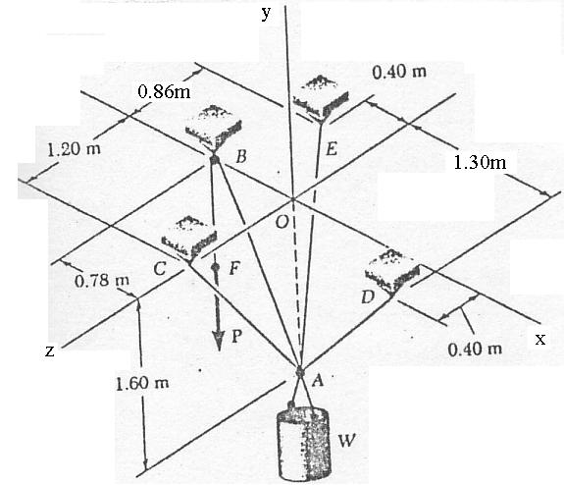 | 15
5. | - The cylinders A and B weighting 1000 N and 2000N. It is given that radius of A is 0.60m and radius of B is 1.2m. Determine the forces exerted at the contact points.  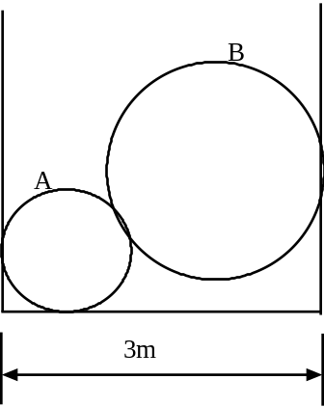  - Determine the stretch in each spring for equilibrium of the block of mass M. The springs are shown in the equilibrium position. Where Mass (M) = 2 Kg, a = 3 m, b = 3m, c = 4 m, K_{AB} = 30 N/m, K_{AC} = 20 N/m , K_{AD} =40 N/m  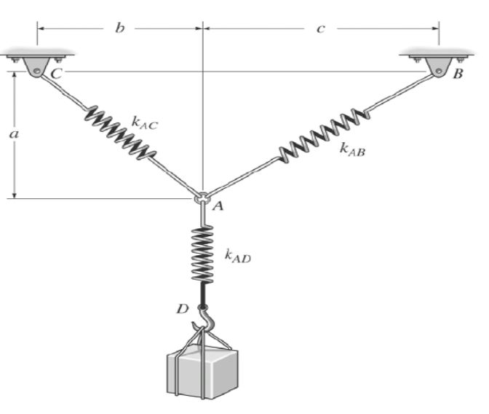 | 7  8
6. | - Describe angle of friction with suitable example and net sketch. Also write law of friction.  - Two identical blocks A and B are connected by a rod and rest respectively against vertical wall and horizontal floor as shown. The sliding motion of the blocks impends when rod makes an angle of 45⁰ with the horizontal. Estimate the coefficient of friction assuming it is to be same both at the floor and wall.  Wall  B  A  Floor  Rod  45⁰ | 5  10
7. | Write short notes on (Any Two):  - Relation between loading, shear force and bending moment  - Co-ordinate System  - Moment about Z-axis | 2×5

